**INTRODUCTION**

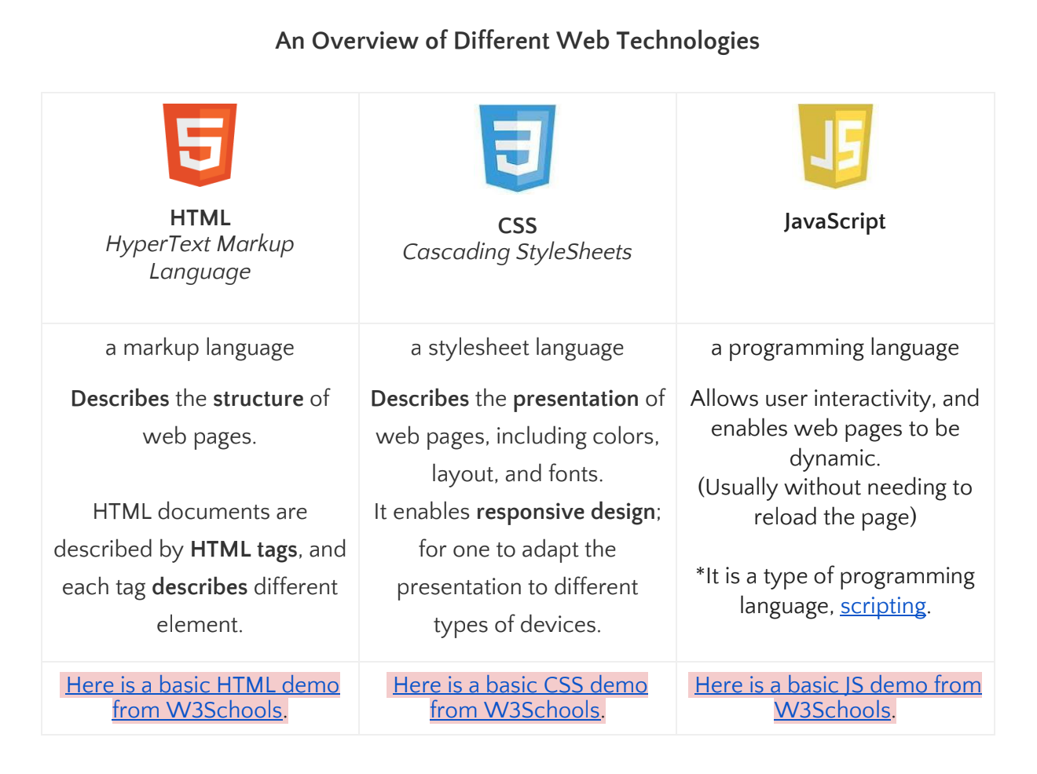

Go to the Website, two fingers click and select ‘Inspect’. You can check out the inside of every websites OR go from menu above, view, developer, view source. Contains HTML, CSS and JavaScript. Right panel is CSS and left is HTML. 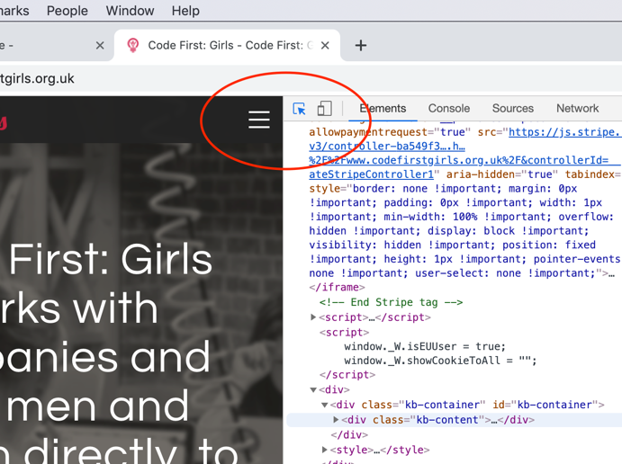

Click here then can find whatever element. Otherwise, can select elements and wlso double finger click to find it straight away.

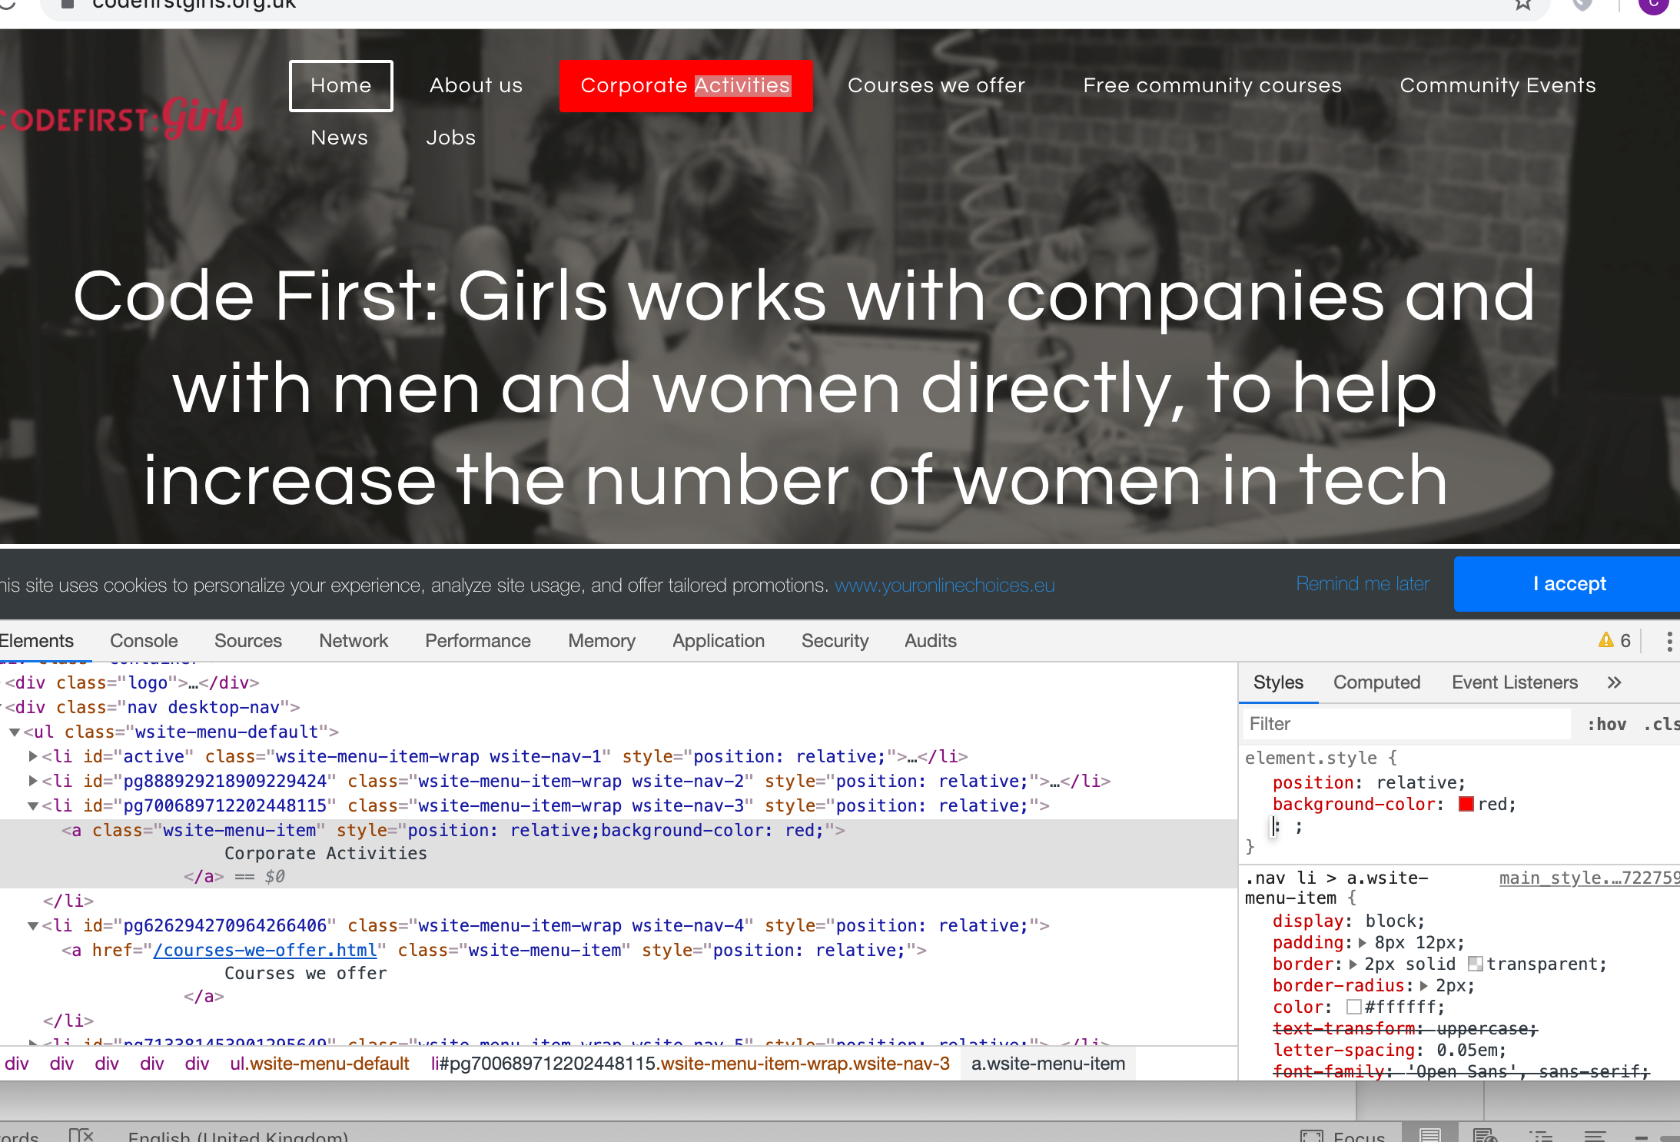

The right column is the attributes inside the property who is the left column.

**Getting going & HTML**

CHAPTER 1

* What is the internet and how does it work?

Computers = servers

Computers= clients

Clients go to providers and do not go on the internet directly.

Servers provide info to websites or other services, directly connected to the interned,

How can computers communicate with each other and understand their own language.

* Static vs dynamic sites

We will learn how to build static pages.

Second level is dynamic websites with Python.

* Server-side technologies
* Putting up a website

Making it public by using hosting services which is a provider e.g godaddy.com to host the website. Then need a domain name to point towards and register it to make it unique.

* What makes a website?

A collection of web pages, plan language ones. The main entry page is nearly always a file called index.html.

Chapter 2: What makes a website?

Summary of the functions

|  |  |  |
| --- | --- | --- |
| HTML | words | The backbone |
| CSS | style | How it looks |
| JavaScript | scripts | How it interacts |
| Image, audio… | media | entertainment |

**Part 1 - HTML**

Chapter 3 - Hello world

Chapter 4 - HTML Basics

Elements, Tags & Attributes

Good Code

HTML DOM

HTML Syntax.

Homework for week 1